1. How is statement coverage determined?
   1. Number of executable statements tested divided by the total number of executable statements
   2. Number of possible test case outcomes divided by the total number of function points
   3. Number of test decision points divided by the number of test cases
   4. Number of decision outcomes tested divided by the total number of decision outcomes
2. Given the state diagram, which test case is the minimum series of valid transitions to cover every state?

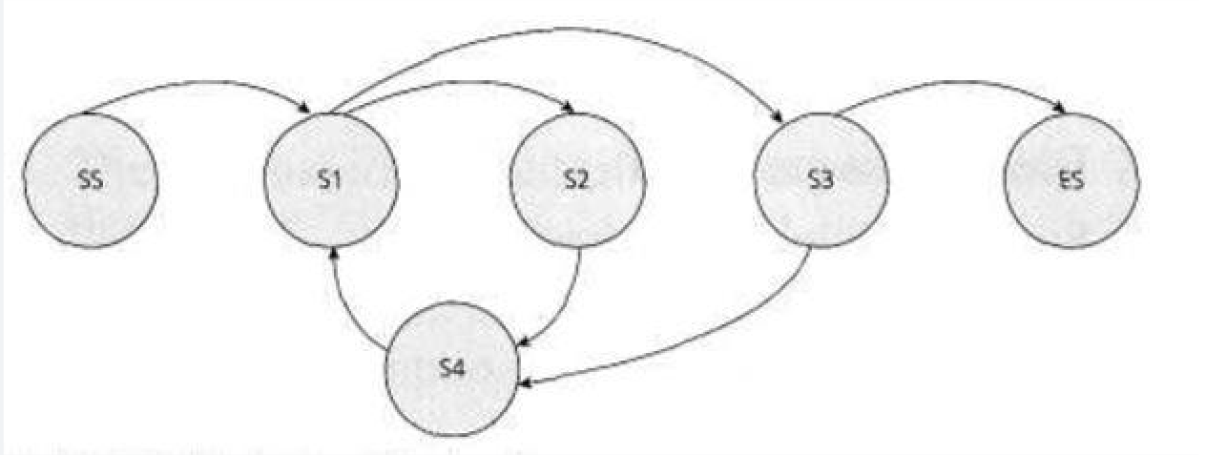

* 1. SS-S1-S2-S4-S1-S3-ES
  2. SS-S1-S4-S2-S1-S3-ES
  3. SS-S1-S2-S4-S1-S3-S4-S1-S3-ES
  4. SS-S1-S2-S3-S4-ES

1. Evaluate the following control flow diagram and determine the statement coverage and decision coverage resulting from the execution of the following test cases:

A-B-D-E-F A-B-C

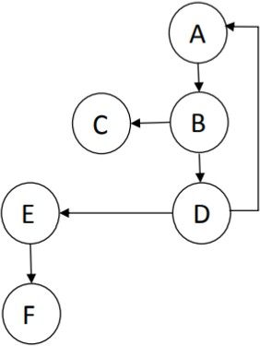

1. 50 % statement, 50 % decision
2. 33 % statement, 100 % decision
3. 100 % statement, 100 % decision
4. 100 % statement, 75 % decision
5. If you need to attain a certain level of code coverage for a particular software product your team is testing, what type of testing should you use?
   1. Behavior-based
   2. Defect-based
   3. Experience-based
   4. Structure-based
6. Given the following program fragment:

If day =Monday then statement a Else

statement b End if

If day = Tuesday then statement c

End if

What is the minimum number of test cases needed to achieve 100% statement coverage?

A. 3

B. 1

C. 4

D. 2

1. The digital rainbow thermometer uses 7 colors to show the ambient temperature. Each color spans a range of just 5, with an operating minimum and maximum of minus 5 and 30, Which of the following values is Least likely to have been identified when applying the boundary value test design technique?
   1. 15-20
   2. 0-5
   3. 25-30
   4. 8-15
2. If you are testing a module of code, how do you determine the level of decision coverage you have achieved?
   1. By taking the number of decision outcomes you have tested and dividing that by the total number of decision outcomes in the module
   2. By taking the number of decisions you have tested and dividing that by the total lines of code in the module
   3. By taking the number of decisions you have tested and dividing that by the total number of decisions in the module
   4. By taking the number of decisions you have tested and dividing that by the total number of executable statements in the module
3. Which of the following is an extension of equivalence partitioning?
   1. State Transition Testing
   2. Decision Testing
   3. Decision Tables
   4. Boundary Value Analysis
4. Which is not true-The black box tester
   1. should be able to understand a functional specification or requirements document
   2. is creative to find the system’s weaknesses
   3. is highly motivated to find faults
   4. should be able to understand the source code.
5. If the temperature falls below 18 degrees, the heating is switched on. When the temperature reaches 21 degrees, the heating is switched off. What is the minimum set of test input values to cover all valid equivalence partitions?
   1. 17,18,20 and 21 degrees
   2. 16 and 26 degrees
   3. 18,20 and 22 degrees
   4. 15,19 and 25 degrees
6. What is exploratory testing?
   1. Concurrent test design, test execution, test logging and learning
   2. The testing carried out by a chartered engineer
   3. A systematic approach to identifying specific equivalent classes of input
   4. The process of anticipating or guessing where defects might occur
7. Which of the following statements are true for the equivalence partitioning test technique?
   1. Divides possible inputs into classes that have the same behavior
   2. Uses both valid and invalid partitions.
   3. Makes use only of valid partitions.
   4. Must include at least two values from every equivalence partition.
   5. Can be used only for testing
8. A and E
9. A and B
10. A , B and E
11. A, C and D
12. Which of the following could be used to assess the coverage achieved for black-box test techniques?

V Decision outcomes exercised W Partitions exercised

X Boundaries exercised

Y State transitions exercised

Z Statements exercised

1. V,X or Z
2. W, X, Y or Z
3. V,W,Y or Z
4. W,X or Y
5. In a system designed to work out the tax to be paid: An employee has £4000 of salary tax free. The next £1500 is taxed at 10% The next £28000 is taxed at 22% Any further amount is taxed at 40% Which of these groups of numbers would fall into the same equivalence class?
   1. 28001, 32000, 35000
   2. 5800, 28000, 32000
   3. 5200, 5500, 28000
   4. 4800, 14000, 28000
6. With a highly experienced tester with a good business background, which approach to defining test procedures would be effective and most efficient for a project under severe time pressure?
   1. A high-level outline of the test conditions with the steps to take discussed in detail with another experienced tester
   2. Detailed documentation of all test cases and careful records of each step taken in the testing
   3. A high-level outline of the test conditions and general steps to take
   4. Every step in the test spelled out in detail
7. You are testing a machine that scores exam papers and assigns grades. Based on the score achieved the grades are as follows:

1-49 = F, 50-59 = D-, 60-69 = D, 70-79 = C, 80-89 = B, 90-100=A

If you apply boundary value analysis, how many test cases will you need to achieve minimum test coverage?

1. 14
2. 8
3. 12
4. 10
5. Which of the following statements about the given state table is TRUE?

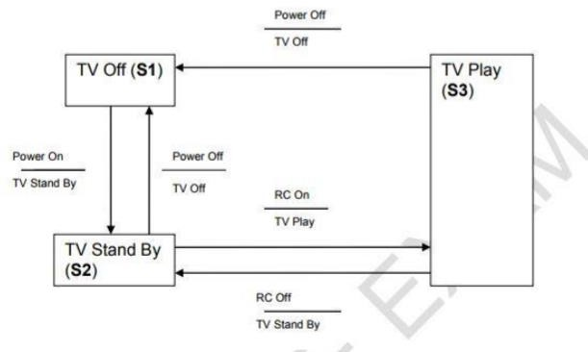

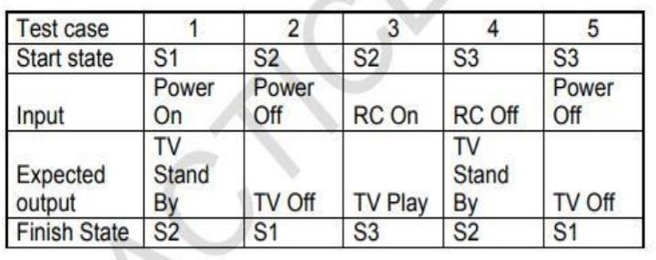

* 1. The state table represents sequential pairs of transitions.
  2. The state table represents all possible single transitions
  3. The state table represents only some of all possible single transitions
  4. The state table can be used to derive both valid and invalid transitions

1. Order numbers on a stock control system can range between 10000 and 99999 inclusive. Which of the following inputs might be a result of designing tests for only valid equivalence classes and valid boundaries
   1. 1000, 5000, 99999
   2. 10000, 50000, 99999
   3. 9999, 50000, 100000
   4. 10000, 99999
2. One of the test goals for the project is to have 100% decision coverage

The following three tests have been executed for the control flow graph shown below. Test A covers path: A, B, D, E, G.

Test B covers path: A, B, D, E, F, G.

Test C covers path: A, C, F, C, F, C, F, G.

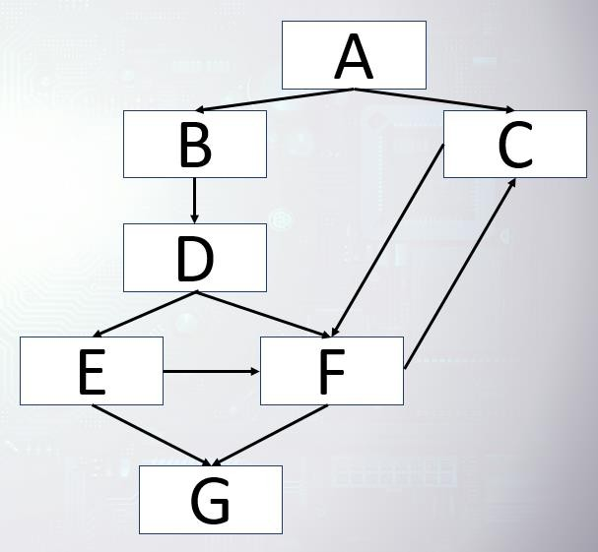

Which of the following statements related to the decision coverage goal is correct ?

1. 100 % decision coverage has been achieved
2. Decision C has not been tested completely
3. Decision D has not been tested completely
4. Decision F has not been tested completely
5. Which of the following black-box testing techniques focuses on covering all combinations of triggering conditions?
   1. Decision Table Testing
   2. Equivalence Partitioning
   3. Boundary Value Analysis
   4. State Transition Testing
6. You are testing a scale system that determines shipping rates for a regional web-based auto parts distributor. Due to regulations, shipments cannot exceed 100 lbs. You want to include boundary value analysis as part of your black-box test design.

How many tests will you need to execute to achieve 100% boundary value analysis?

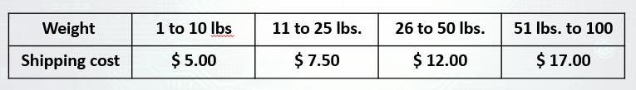

1. 8
2. 12
3. 4
4. 10
5. Which of the following is a good reason to use experience-based testing?
   1. You can test for defects that only experienced users would encounter
   2. You can find defects that might be missed by more formal techniques
   3. You can target the developer’s efforts to the areas that users will be more likely to use
   4. It is supported by strong tools and can be automated
6. Postal rates for ‘light letters’ are 25p up to 10g, 35p up to 50g plus an extra 10p for each additional 25g up to 100g. Which test inputs (in grams) would be selected using boundary value analysis?
   1. 0,9,19,49,50,74,75,99,100
   2. 10,50,75,100,250
   3. 1,10,11,50,51,75,76,100
   4. 0,1,10,11,50,51,75,76,100,101
7. Consider the above state transition diagram of a switch, Which of the following represents an invalid state transition

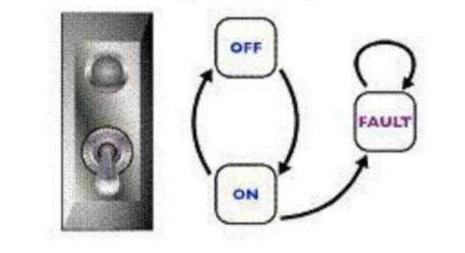

* 1. On to Off
  2. Fault to Fault
  3. Off to On
  4. Fault to On

1. Which one of the following techniques is structure-based?
   1. Equivalence Partitioning
   2. Decision Testing
   3. Boundary Value Analysis
   4. State Transition Testing
2. Which of the following could be a coverage measure for state transition testing?

V All states have been reached

W The response time for each transaction is adequate X Every transition has been exercised

Y All boundaries have been exercised

Z Specific sequences of transitions have been exercised

1. W,X and Y
2. V, X and Z
3. V, X, Y and Z
4. X,Y and Z
5. One technique of Black Box testing is Equivalence Partitioning. In a program statement that accepts only one choice from among 10 possible choices, numbered 1 through 10, the middle partition would be from to
   1. No answer is correct
   2. 4 to 6
   3. 0 to 10
   4. 1 to 10
6. A defect was found during testing. When the network got disconnected while receiving data from a server, the system crashed. The defect was fixed by correcting the code that checked the network availability during data transfer. The existing test cases covered 100% of all statements of the corresponding module. To verify the fix and ensure more extensive coverage, some new tests were designed and added to the test suite.

What types of testing are mentioned above? A.Functional Testing

B.Structural Testing C.Re-testing D.Performance Testing

* 1. A,B and D
  2. A,B and C
  3. A,C and D
  4. A and C

1. If you are using error guessing to target your testing, which type of testing are you doing?
   1. Behavior-based
   2. Experience-based
   3. Structure-based
   4. Reference-based
2. If the test cases time = 11 and time = 15 were input, what level of decision coverage would be achieved?

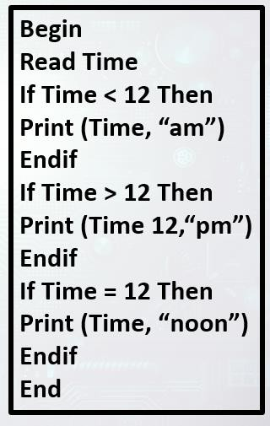

* 1. 100 % or 6/6
  2. 67 % or 4/6
  3. 83 % or 5/6
  4. 50 % or 3/6

1. Which of the following statements about the given state table is TRUE?

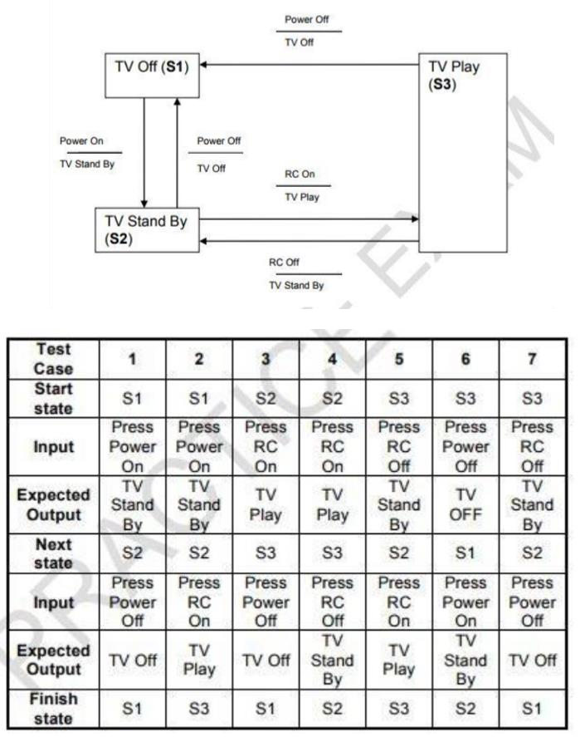

* 1. The test case gives only the invalid state transitions
  2. The test case gives only the valid state transitions
  3. The test case table exercises the shortest number of transitions
  4. The test case exercises the longest number of transitions

1. Income tax is set a flat rate of 20% per annum for all incomes but with 2 exceptions. Tax exemption is given for incomes below 5000 EGP per annum. Also, families with single worker and more than five members get 5% tax reductions. What is the number of test cases generated using decision table testing when having one test case per each table rule?

A. 8

B. 4

C. 3

D. 6

1. What is the expected result for each of the following test cases?
2. Frequent flyer member, travelling in Business class
3. Non-member, travelling in Economy class

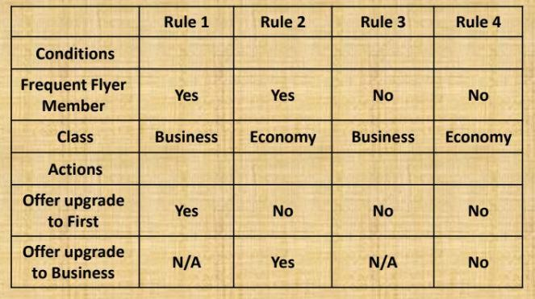

* 1. A – Don’t offer any upgrade, B – Offer upgrade to business
  2. A – don’t offer any upgrade, B – Don’t offer any upgrade
  3. A – Offer upgrade to first, B – Offer upgrade to business
  4. A – Offer upgrade to First, B – Don’t offer any upgrade

1. If you are using a testing technique to identify test cases that were missed when you applied formal testing techniques, what type of test design are you doing?
   1. Defect-based
   2. Experience-based
   3. Informal
   4. Ad hoc
2. For the following state transition diagram

What is the number of test cases required to test all the transitions in it? Consider that each test case starts at the "Start" State and ends at a dead state

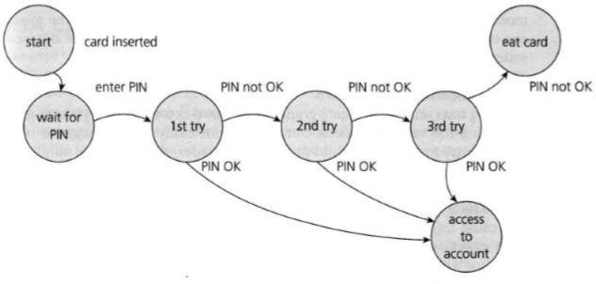

A. 6

B. 3

C. 5

D. 4

1. Minimum Tests required for statement coverage and branch coverage

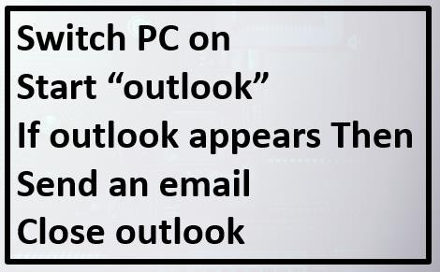

* 1. Statement Coverage is 1, Branch Coverage is 1
  2. Statement Coverage is 2, Branch Coverage is 2
  3. Statement Coverage is 1, Branch Coverage is 2
  4. Statement Coverage is 2, Branch Coverage is 3

1. Which of the following is a valid collection of equivalence classes for the following problem: An integer field shall contain values from and including 1 to and including 15
   1. Less than 1, 1 through 14, more than 15
   2. Negative numbers, 1 through 15, above 15
   3. Less than 1, 1 through 15, more than 15
   4. Less than 0, 1 through 14, 15 and more
2. You are testing a machine that scores exam papers and assigns grades. Based on the score achieved the grades are as follows:

1-49 = F, 50-59 = D-, 60-69 = D, 70-79 = C, 80-89 = B, 90-100=A

If you apply equivalence partitioning, how many test cases will you need to achieve minimum test coverage?

1. 6
2. 12
3. 8
4. 10
5. Put the test cases that implement the following test conditions into the best order for the test execution schedule, for a test that is checking modifications of customers on a database.
6. Print modified customer record.
7. Change customer address: house number and street name.
8. Capture and print the on-screen error message.
9. Change customer address: postal code.
10. Confirm existing customer is on the database by opening that record.
11. Close the customer record and close the database.
12. Try to add a new customer with no details at all.
    1. 5,4,2,1,7,3,6
    2. 5,4, 2,1, 3, 7, 6
    3. 4,2,5,1,6,7,3
    4. 5,1, 2, 3,4, 7, 6
13. Minimum Tests required for statement coverage and branch coverage

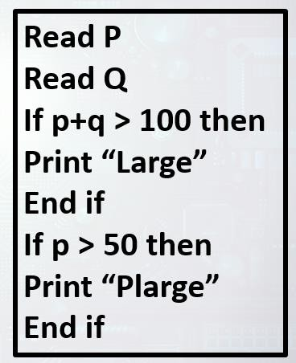

* 1. Statement coverage is 1, Branch coverage is 3
  2. Statement coverage is 2, Branch coverage is 2
  3. Statement coverage is 1, Branch coverage is 2
  4. Statement coverage is 4, Branch coverage is 2

1. If test cases are derived from looking at the code, what type of test design technique is being used?
   1. Behavior-based
   2. White Box
   3. Experience-based
   4. Black Box Explanation

Looking at the code means that you are performing white box testing (architecture or structure based)

1. What does it mean if a set of tests has achieved 90% statement coverage?
   1. 9 out of 10 tests have been run on this set of software
   2. 9 out of 10 decision outcomes have been exercised by this set of tests
   3. 9 out of 10 statements have been exercised by this set of tests
   4. 9 out of 10 requirements statements about the software are correct
2. What is the expected result for each of the following test cases?
   1. Citibank card member, holding a silver room
   2. Non Citibank member, holding a platinum room

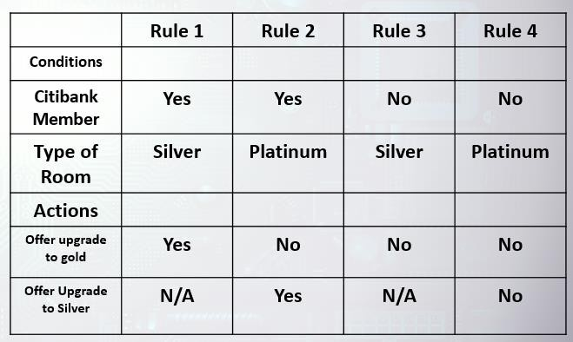

1. A – Offer upgrade to silver, B – Offer upgrade to silver
2. A – Offer upgrade to gold, B – Don’t offer any upgrade
3. A – Don’t offer any upgrade, B – Offer upgrade to gold
4. A – don’t offer any upgrade, B – Don’t offer any upgrade
5. Which of the following test techniques uses the requirements specifications as the test basis?
   1. White-box
   2. Exploratory
   3. Black-box
   4. Structure-based
6. Which of the following best describes the behaviors defined in a use case that should be covered by tests?
   1. Basic, exception and error
   2. Normal, error, data, and integration
   3. Positive path and negative path
   4. Control flow, data flow and decision paths
7. When should the expected results of a test case be defined?
   1. When the test condition is identified
   2. When the test case is executed
   3. When the test case is written, prior to execution
   4. When the risk is assessed
8. What do use cases describe?
   1. Code flows
   2. Data flows
   3. Control flows
   4. Process Flows
9. An input field takes the year of birth between 1900 and 2004. The boundary values for testing this field are
   1. 0,1900,2004,2005
   2. 1899,1900,2004,2005
   3. 1899,1900,1901,2003,2004,2005
   4. 1900,2004
10. How many test cases are necessary to cover all the possible sequences of statements (paths) for the following program fragment?

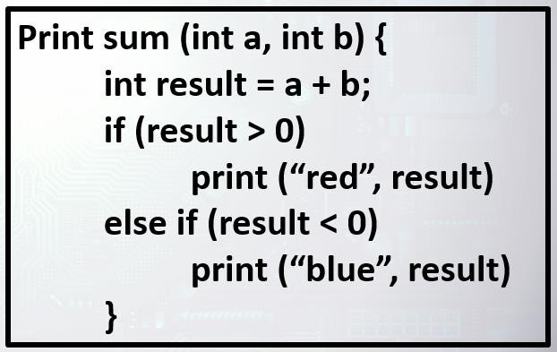

A. 4

B. 2

C. 3

D. 1

1. Which of the following is the correct decision table for the following pseudocode for ordering a hamburger?

Note: if you add or delete items from the basic burger, you no longer get the basic burger.

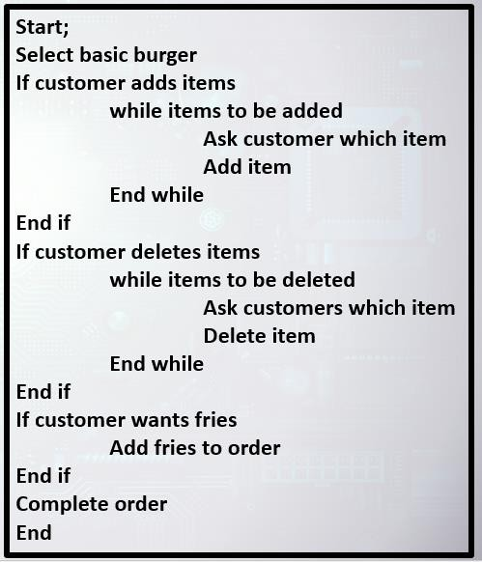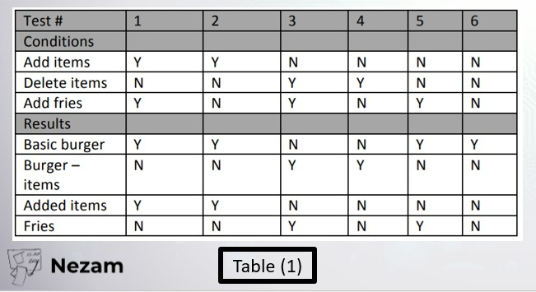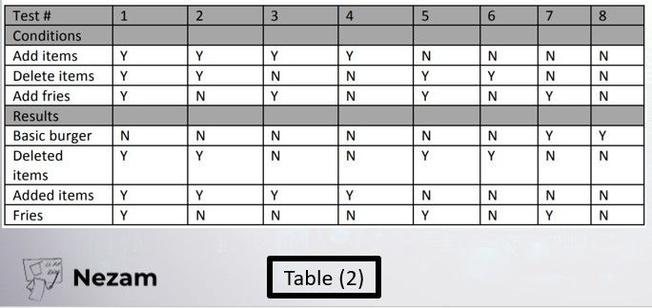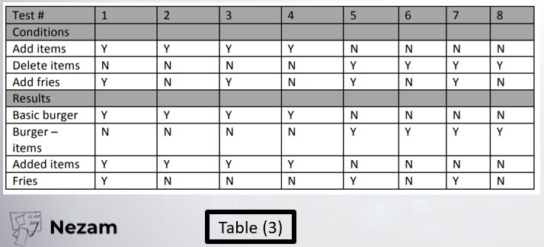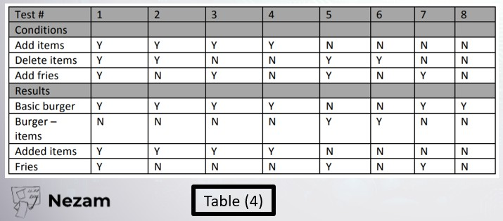

1. Table 2
2. Table 3
3. Table 1
4. Table 4
5. Consider the following high level program design and assume you can provide the values for today, A, B and C:

Start;

Do until B = C

If today = Monday set A = 1

elseif today = Wednesday set A = 2

set B = C

Endif;

If B < C

B = B + 1

Endif;

Endloop;

End;

Which of the following sets of values will achieve 100% decision coverage with the least number of test cases (the order of the values is today, A, B, C)?

1. Monday, 5, 1, 1; Tuesday, 5, 1, 2; Wednesday, 5, 1, 2
2. Monday, 1, 3, 3; Monday 3, 2, 4; Wednesday, 1, 2, 3; Tuesday, 5, 4, 3
3. Monday, 1, 2, 4; Wednesday 1, 2, 4
4. Monday, 5, 3, 2; Monday, 5, 1, 1; Monday 5, 2, 3; Tuesday, 4, 4, 3; Wednesday, 1, 2, 3
5. What is the expected result for each of the following test cases? A.TC1: Fred is a 32 year old smoker resident in London B.TC3: Jean-Michel is a 65 year non-smoker resident in Paris

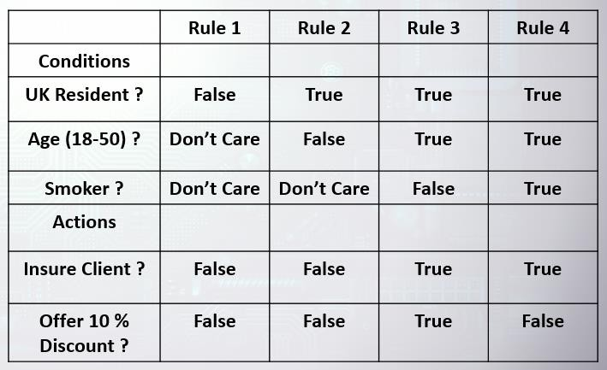

* 1. A – Insure, no discount, B – Don’t insure
  2. A – Don’t insure, B – Don’t insure
  3. A – Insure, no discount, B – Insure with 10% discount
  4. A – Insure, 10% discount, B – Insure, no discount.

1. Consider the following control flow chart:

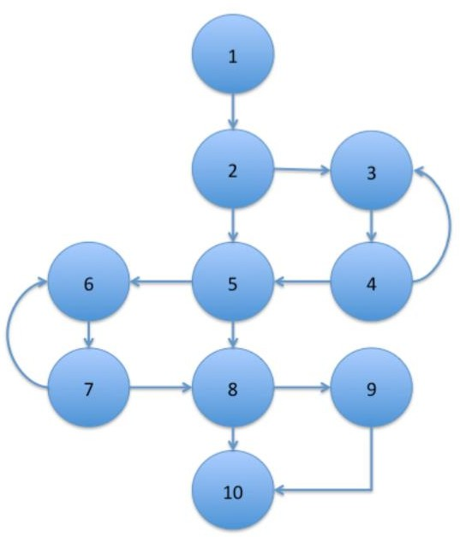

You have run one test case: 1-2-3-4-5-6-7-8-9-10

What percentage of decision coverage have you achieved?

1. 50 %
2. 90 %
3. 100 %
4. 80 %
5. Given this decision table, what is the expected result for the following test cases?

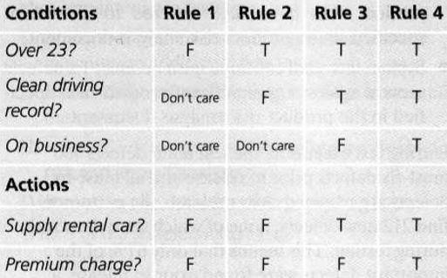

TCI: A 26-year-old on business but with violations or accidents on his driving record TC2: A 62-year-old tourist with a clean driving record

* 1. TCI: Don't supply car; TC2: Supply car with no premium charge
  2. TCI: Supply car with premium charge; TC2: Supply car with no premium charge
  3. TCI: Supply car with premium charge; TC2: Don't supply car
  4. TCI: Don't supply car; TC2: Supply car with premium charge.

1. A programmer validates a numeric field as follows: Values less than 10 are rejected, values between 10 and 21 are accepted, values greater than or equal to 22 are rejected Which of the following input values cover all of the equivalence partitions?
   1. 10,21,22
   2. 3,20,21
   3. 3,10,22
   4. 10,11,12

Explanation

Here, the programmer has three partitions. the first is less than 10, the second is between 10 and 21, and the third is more than or equal to 22. So we need to choose three values which cover all the three partitions

1. You are testing a scale system that determines shipping rates for a regional web-based auto parts distributor. You want to group your test conditions to minimize the testing. Identify how many equivalence classes are necessary for the following range. Weights are rounded to the nearest pound

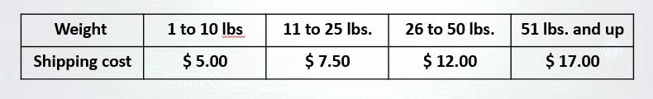

A. 6

B. 4

C. 5

D. 8

1. Which two Black Box testing techniques are most closely related to each other?
   1. Equivalence partitioning and boundary value analysis
   2. Equivalence partitioning and state transition testing
   3. Decision tables and boundary value analysis
   4. Decision tables and state transition testing
2. Given this diagram, which test case below covers every valid transition?

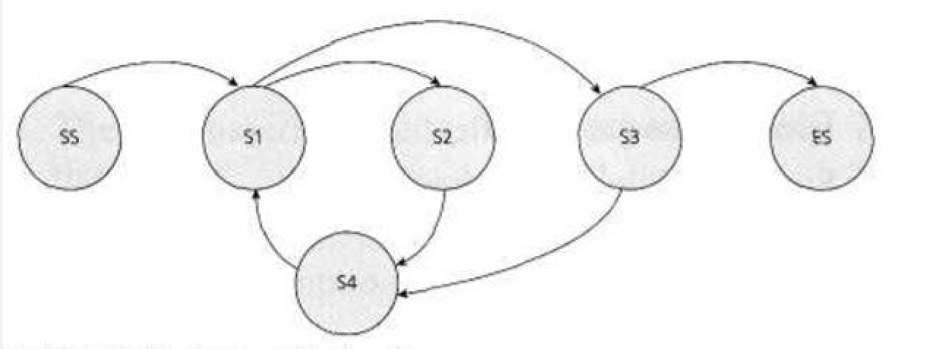

* 1. SS-S1-S2-S4-S1-S3-ES
  2. SS-S1-S2-S4-S1-S3-S4-S1-S3-ES
  3. SS-S1-S4-S2-S1-S3-ES
  4. SS-S1-S2-S3-S4-S3-S4-ES

1. Which of the following would be the best test approach when there are poor specifications and time pressures?
   1. Path testing
   2. Exploratory testing
   3. Condition coverage
   4. Use case testing
2. Which of the following is correct?
   1. 100% statement coverage guarantees 100% decision coverage
   2. 100% branch coverage guarantees 100% statement coverage.
   3. 100% branch coverage guarantees 100% path coverage.
   4. 100% statement coverage guarantees 100% branch coverage.
3. Statement Coverage will not check for the following?
   1. Missing Statements
   2. Unused statement
   3. Dead Code
   4. Unused branches
4. In a flight reservation system, the number of available seats in each plane model is an input. A plane may have any positive number of available seats, up to the given capacity of the plane. Using Boundary Value analysis, a list of available – seat values were generated. Which of the following lists is correct?
   1. 0, 1, 2, capacity plus 1, a very large number
   2. 1, 2, capacity -1, capacity, capacity plus 1
   3. 0, 1, 10, 100, capacity, capacity plus one
   4. 0, 1, capacity, capacity plus 1
5. For the following state transition diagram

What is the number of test cases required to test all the states in it "pass at each state at least one time"?

Consider that each test case starts at the "Start" State and ends at a dead state



A. 5

B. 3

C. 2

D. 4

1. In a system designed to work out the tax to be paid: An employee has £4000 of salary tax free. The next £1500 is taxed at 10% The next £28000 is taxed at 22% Any further amount is taxed at 40% Which of these is a valid boundary value analysis test case?
   1. 32001
   2. 33501
   3. 1500
   4. 28000
2. You are testing a medical application that is used only by teenagers, which of the following inputs can be used if we apply equivalence partitioning technique on this system?
   1. 12, 15, 18
   2. 12, 15, 20
   3. 9, 15, 19
   4. 13, 18, 25

Explanation

Teenagers are in the age between 13 & 19

1. Find the Equivalence class for the following test case. Enter a number to test the validity of being accepting the numbers between 1 and 99
   1. All numbers > 99
   2. All numbers between 1 and 99
   3. All numbers < 1
   4. Number = 0
2. Which of the following solutions below lists techniques that can be categorized as Black Box design techniques?
   1. Equivalence Partitioning, cause-effect graph, checklist based, decision coverage, use case
   2. Equivalence Partitioning, decision tables, checklist based, statement coverage, use case
   3. Equivalence Partitioning, cause-effect graph, checklist based, decision coverage and boundary value
   4. Equivalence Partitioning, decision tables, & use case testing
3. A programmer validates a numeric field as follows: Values less than 10 are rejected, values between 10 and 21 are accepted, values greater than or equal to 22 are rejected Which of the following input values cover The most boundary values?
   1. 10,11,21,22
   2. 9,10,11,12
   3. 9,10,21,22
   4. 10,11,20,21
4. Given the following specification, which of the following values for age are in the same equivalence partition? If you are less than 18, you are too young to be insured. Between 18 and 30 inclusive, you will receive a 20% discount. Anyone over 30 is not eligible for a discount
   1. 18,29,30
   2. 17,29,31
   3. 29,30,31
   4. 17,18,19
5. An employee’s bonus is to be calculated. It cannot become negative, but it can be calculated to zero. The bonus is based on the duration of the employment. An employee can be employed for less than or equal to 2 years, more than 2 years but less than 5 years, 5 to 10 years, or longer than 10 years. Depending on this period of employment, an employee will get either no bonus or a bonus of 10%, 25% or 35%

How many valid equivalence partitions are needed to test the calculation of the bonus?

A. 2

B. 4

C. 5

D. 3

1. You have started behavior-based testing of a program. It calculates the greatest common divisor (GCD) of two integers (A and B) greater than zero calcGCD (A, B);

The following test cases (TC) have been specified

Which test technique has been applied in order to determine test cases 1 through 6?

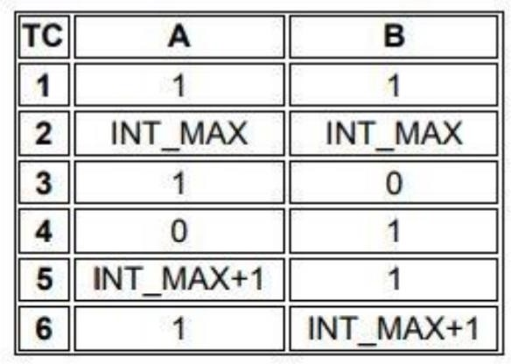

1. Boundary value analysis
2. Equivalence partitioning
3. State transition testing
4. Decision Table
5. Consider the following control flow chart:

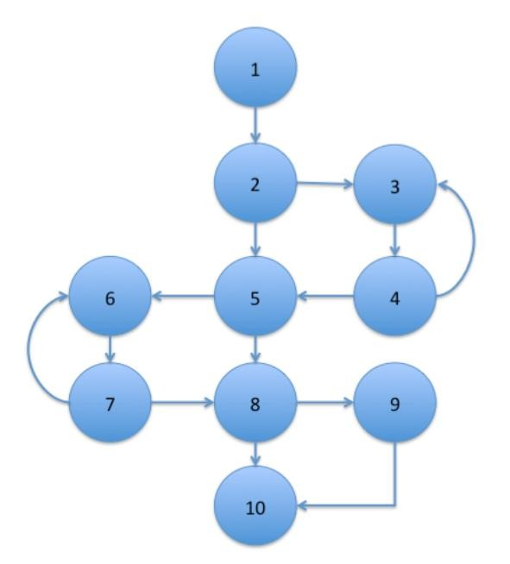

You have run one test case: 1-2-3-4-5-6-7-8-9-10

What percentage of statement coverage have you achieved?

1. 80 %
2. 50 %
3. 100 %
4. 90%
5. If you are flying with an economy ticket, there is a possibility that you may get upgraded to business class, especially if you hold a gold card in the airline's frequent flyer program. If you don't hold a gold card, there is a possibility that you will get 'bumped' off the flight if it is full and you check in late. Note that each box (i.e. statement) has been numbered. Three tests have already been run:

Test 1: Gold card holder who gets upgraded to business class Test 2: Non-gold card holder who stays in economy

Test 3: A person who is bumped from the flight

What additional tests would be needed to achieve 100% decision coverage?

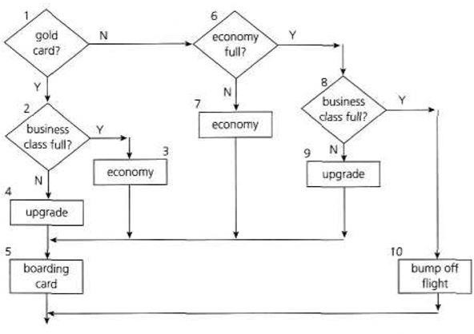

1. A gold card holder and a non-gold card holder who are both upgraded to business class
2. A gold card holder and a non-gold card holder who both stay in economy class
3. A gold card holder who is upgraded to business class and a non-gold card holder who stays in economy class
4. A gold card holder who stays in economy and a non-gold card holder who gets upgraded to business class
5. What is checklist-based testing?
6. A test technique in which tests are derived based on the tester's knowledge of past faults,

or general knowledge of failures.

1. Procedure to derive and/or select test cases based on an analysis of the specification, either functional or non-functional, of a component or system without reference to its internal structure.
2. An experience-based test technique whereby the experienced tester uses a list of items to

be noted, checked, or remembered, or a set of rules or criteria against which a product has to be verified.

1. An approach to testing where the testers dynamically design and execute tests based on their knowledge, exploration of the test item and the results of previous tests
2. Which one of the following options is categorized as a black-box test technique?
3. A technique based on analysis of the architecture.
4. A technique checking that the test object is working according to the technical design.
5. A technique based on the knowledge of past faults, or general knowledge of failures.
6. A technique based on formal requirements.
7. The following statement refers to decision coverage:

“When the code contains only a single ‘if’ statement and no loops or CASE statements, and its

execution is not nested within the test, any single test case we run will result in 50% decision

coverage.”

Which of the following statement is correct?

1. The statement is true. Any single test case provides 100% statement coverage and therefore 50% decision coverage.
2. The statement is true. Any single test case would cause the outcome of the “if” statement to

be either true or false.

1. The statement is false. A single test case can only guarantee 25% decision coverage in this

case.

1. The statement is false. The statement is too broad. It may be correct or not, depending on

the tested software

1. Which one of the following is the description of statement coverage?
2. It is a metric, which is the percentage of test cases that have been executed.
3. It is a metric, which is the percentage of statements in the source code that have been executed.
4. It is a metric, which is the number of statements in the source code that have been executed by test cases that are passed.
5. It is a metric, that gives a true/false confirmation if all statements are covered or not
6. Which statement about the relationship between statement coverage and decision coverage is

true?

1. 100% decision coverage also guarantees 100% statement coverage.
2. 100% statement coverage also guarantees 100% decision coverage.
3. 50% decision coverage also guarantees 50% statement coverage.
4. Decision coverage can never reach 100%
5. For which of the following situations is explorative testing suitable?
6. When time pressure requires speeding up the execution of tests already specified.
7. When the system is developed incrementally and no test charter is available.
8. When testers are available who have sufficient knowledge of similar applications and technologies.
9. When an advanced knowledge of the system already exists and evidence is to be provided

that it should be tested intensively

1. An employee’s bonus is to be calculated. It cannot be negative, but it can be calculated down to

zero. The bonus is based on the length of employment:

* less than or equal to 2 years,
* more than 2 years but less than 5 years,
* 5 to 10 years inclusively or longer than 10 years.

What is the minimum number of test cases required to cover all valid equivalence partitions for

calculating the bonus?

1. 3.
2. 5.
3. 2.
4. 4.
5. A speed control and reporting system has the following characteristics: If you drive 50 km/h or less, nothing will happen.

If you drive faster than 50 km/h, but no more than 55 km/h, you will be warned. If you drive faster than 55 km/h but not more than 60 km/h, you will be fined.

If you drive faster than 60 km/h, your driving license will be suspended. The speed in km/h is available to the system as an integer value.

Which would be the most likely set of values (km/h) identified by applying the boundary value

analysis, where only the boundary values on the boundaries of the equivalence classes are relevant?

1. 0, 49, 50, 54, 59, 60.
2. 50, 55, 60.
3. 49, 50, 54, 55, 60, 62.
4. 50, 51, 55, 56, 60, 61.
5. A company's employees are paid bonuses if they work more than a year in the company and

achieve a target which is individually agreed before. These facts can be shown in a decision table:

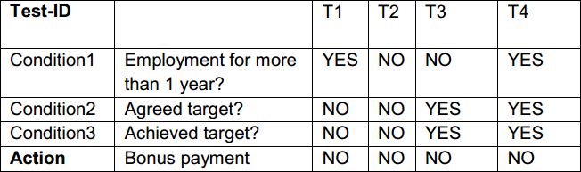

Which of the following test cases represents a situation that can happen in real life,and is missing in the above decision table?

1. Condition1 = YES, Condition2 = NO, Condition3 = YES, Action= NO
2. Condition1 = YES, Condition2 = YES, Condition3 = NO, Action= YES
3. Condition1 = NO, Condition2 = NO, Condition3 = YES, Action= NO
4. Condition1 = NO, Condition2 = YES, Condition3 = NO, Action= NO
5. 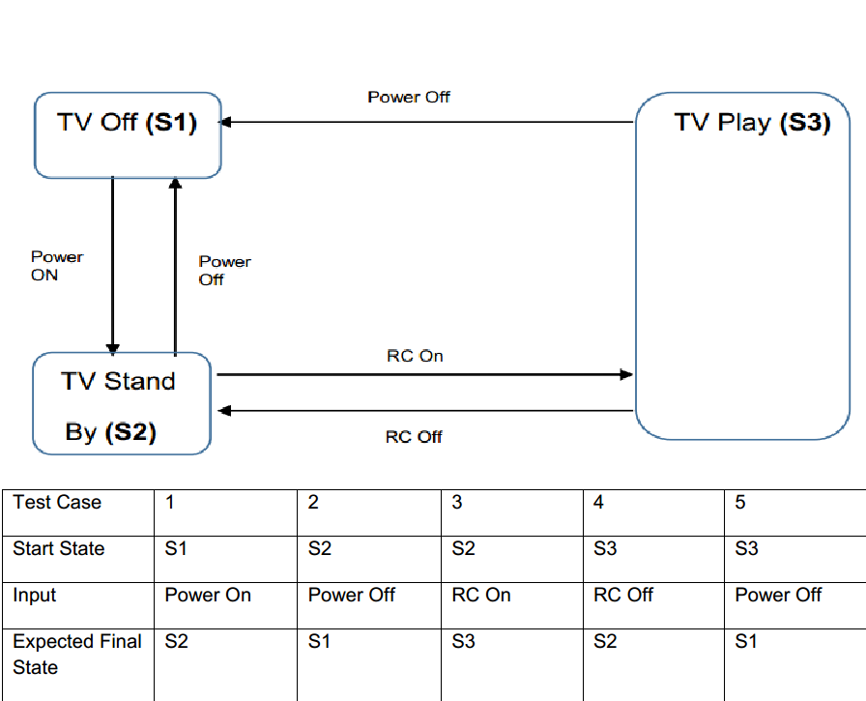Which of the following statements about the given state transition diagram and table of test cases is TRUE?
6. The given test cases cover both valid and invalid transitions in the state transition diagram.
7. The given test cases represent all possible valid transitions in the state transition diagram.
8. The given test cases represent some of the valid transitions in the state transition diagram.
9. The given test cases represent pairs of transitions in the state transition diagram
10. A video application has the following requirement: The application shall allow playing a video on the

following display resolution:

1. 640x480.
2. 1280x720.
3. 1600x1200.
4. 1920x1080.

Which of the following list of test cases is a result of applying the equivalence

partitioning test technique to test this requirement?

* 1. Verify that the application can play a video on a display of size 1920x1080 (1 test case).
  2. Verify that the application can play a video on a display of size 640x480 and 1920x1080 (2 test cases).
  3. Verify that the application can play a video on each of the display sizes in the requirement (4 test cases).
  4. Verify that the application can play a video on any one of the display sizes in the requirement (1 test case)

1. Which of the following provides the BEST description of exploratory testing?
2. A testing practice in which an in-depth investigation of the background of the test object is used to identify potential weaknesses that are examined by test cases.
3. An approach to testing whereby the testers dynamically design and execute tests based on their knowledge, exploration of the test item and the results of previous tests.
4. An approach to test design in which test activities are planned as uninterrupted sessions of test analysis and design, often used in conjunction with checklist-based testing.
5. Testing based on the tester's experience, knowledge and intuition
6. Which of the following BEST matches the descriptions with the different categories of test techniques?
7. Coverage is measured based on a selected structure of the test object.
8. The processing within the test object is checked.
9. Tests are based on defects’ likelihood and their distribution.
10. Deviations from the requirements are checked.
11. User stories are used as the test basis.

|  |  |
| --- | --- |
| Black | - Black-box test techniques |
| White | - White-box test techniques |
| Experience | - Experience-based test techniques |
| a) | Black – 4, 5 White – 1, 2  Experience – 3 |
| b) | Black – 3 White – 1, 2 Experience  – 4, 5 |
| c) | Black – 4 White – 1, 2 Experience  – 3, 5 |
| d) | Black – 1, 3, 5 White – 2  Experience – 4 |

1. A fitness app measures the number of steps that are walked each day and provides feedback to encourage the user to keep fit.

The feedback for different numbers of steps should be:

|  |  |
| --- | --- |
| Up to 1000 | - Couch Potato! |
| Above 1000, up to 2000 - Lazy  Bones! |  |
| Above 2000, up to 4000 - Getting  There! |  |
| Above 4000, up to 6000 - Not  Bad! |  |

|  |  |
| --- | --- |
| Above 6000 | - Way to Go! |
| Which of the following sets of test inputs would achieve the highest equivalence partition  coverage? |  |

1. 0, 1000, 2000, 3000, 4000
2. 1000, 2001, 4000, 4001, 6000
3. 123, 2345, 3456, 4567, 5678
4. 666, 999, 2222, 5555, 6666
5. A daily radiation recorder for plants produces a sunshine score based on a combination of the number of hours a plant is exposed to the sun (below 3 hours, 3 to 6 hours or above 6 hours) and the average intensity of the sunshine (very low, low, medium, high).

Given the following test cases:

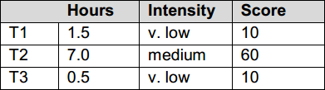

What is the minimum number of additional test cases that are needed to ensure full coverage of all valid INPUT equivalence partitions?

a) 1

b) 2

c) 3

d) 4

1. A smart home app measures the average temperature in the house over the previous week and provides feedback to the occupants on their environmental-friendliness based on this temperature.

The feedback for different average temperature ranges (to the nearest °C) should be:

|  |  |
| --- | --- |
| Up to  10°C | - Icy Cool! |

|  |  |
| --- | --- |
| 11°C to  15°C | - Chilled  Out! |
| 16°C to  19°C | - Cool Man! |
| 20°C to  22°C | - Too Warm! |
| Above  22°C | - Hot &  Sweaty! |

Using two-point BVA, which of the following sets of test inputs provides the highest level of boundary coverage?

* 1. 0oC, 11oC, 20oC, 22oC, 23oC
  2. 9oC, 15oC, 19oC, 23oC, 100oC
  3. 10oC, 16oC, 19oC, 22oC, 23oC
  4. 14oC, 15oC, 18oC, 19oC, 21oC, 22oC

1. Decision table testing is being performed on a speeding fine system. Two test cases have already been generated for rules 1 and 4, which are shown below:

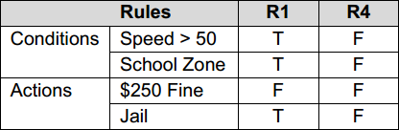

Given the following additional test cases:

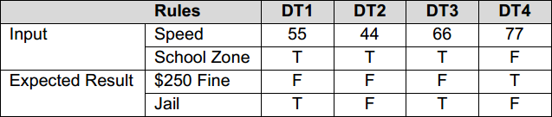

Which two of the additional test cases would achieve full coverage of the complete decision table (when combined with the test cases that have already been generated for rules 1 and 4)?

1. DT1, DT2
2. DT2, DT3
3. DT2, DT4
4. DT3, DT4
5. Given the following state model of a battery charger software:

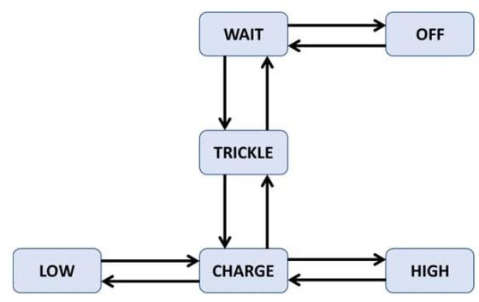

Which of the following sequences of transitions provides the highest level of transition coverage for the

model?

|  |  |  |  |  |  |
| --- | --- | --- | --- | --- | --- |
| a) | OFF → | WAIT → | OFF → | WAIT → | TRICKLE → |
| CHARGE → | HIGH → | CHARGE → | LOW |  |  |
| b) | WAIT → | TRICKLE → | WAIT → | OFF → | WAIT → |
| TRICKLE → | CHARGE → | LOW → | CHARGE |  |  |
| c) | HIGH → | CHARGE → | LOW → | CHARGE → | TRICKLE → |
| WAIT → | TRICKLE → | WAIT → | TRICKLE |  |  |
| d) | WAIT → | TRICKLE → | CHARGE → | HIGH → | CHARGE → |
| TRICKLE → | WAIT → | OFF → | WAIT |  |  |

1. which of the following statements BEST describes how test cases are derived from a use case?
2. Test cases are created to exercise defined basic, exceptional and error behaviors performed by the system under test in collaboration with actors.
3. Test cases are derived by identifying the components included in the use case and creating integration tests that exercise the interactions of these components.
4. Test cases are generated by analyzing the interactions of the actors with the system to ensure the user interfaces are easy to use.
5. Test cases are derived to exercise each of the decision points in the business process flows of the use case, to achieve 100% decision coverage of these flows.
6. Which of the following descriptions of statement coverage is CORRECT?
7. Statement coverage is a measure of the number of lines of source code (minus comments) exercised by tests.
8. Statement coverage is a measure of the proportion of executable statements in the source code exercised by tests.
9. Statement coverage is a measure of the percentage of lines of source code exercised by tests.
10. Statement coverage is a measure of the number of executable statements in the source code exercised by tests
11. Which of the following descriptions of decision coverage is CORRECT?
12. Decision coverage is a measure of the percentage of possible paths through the source code exercised by tests.
13. Decision coverage is a measure of the percentage of business flows through the component exercised by tests.
14. Decision coverage is a measure of the ‘if’ statements in the code that are exercised with both the true and false outcomes.
15. Decision coverage is a measure of the proportion of decision outcomes in the source code exercised by tests.
16. Which of the following BEST describes the concept behind error guessing?
17. Error guessing requires you to imagine you are the user of the test object and guess mistakes the user could make interacting with it.
18. Error guessing involves using your personal experience of development and the mistakes you made as a developer.
19. Error guessing involves using your knowledge and experience of defects found in the past and typical mistakes made by developers.
20. Error guessing requires you to rapidly duplicate the development task to identify the sort of mistakes a developer might make.